Evaluating environmental status
of the Sevastopol coastal aquatoria (Black Sea)

Tatyana Osadchaya, The A.O. Kovalevsky Institute of Marine Biological Researches of RAS (IMBR), ots51@mail.ru
Sergey Alyomov, IMBR, numa_63@mail.ru
Elena Tikhonova, IMBR, tihonoval@mail.ru
Olga Solovieva, IMBR, kozl_ya_oly@mail.ru
Tatyana Viter, IMBR, tatjana-viter@rambler.ru

Abstract. The review reports on the results of comparative analysis the changes in environmental status of some Sevastopol bays located directly in City's boundaries but differing by functional (in terms of economic/industrial use) specificity. Pollution status of studied areas was assessed by concentrations the oil hydrocarbons and chloroform bitumoids in bottom sediments; the patterns of benthic fauna were used to examine the responses of biota to anthropogenic load.

Key words: coastal marine area, oil hydrocarbon pollution, bottom sediments, macrozoobenthos

I. Introduction
Sevastopol region occupies the southwestern part of the Crimean peninsula and on natural resources is one of the richest on the Black Sea coast of Russia. As a regional centre, the city of Sevastopol is one of the most urbanized areas of the Crimea because of a big commercial and industrial port and a historical base of the Black Sea Navy. Traditional for any maritime regions development of the city along the coastline has led to the fact that to date majority of the bays are located immediately in boundaries of city's line. Objective irregularity in distribution of potential sources of contamination on the shores including the residential constructions, shipbuilding or ship repair enterprises, moorings and port structures, recreational areas, etc. determines the volume and intensity the various anthropogenic wastes and discharges, entering into adjoining aquatoria. Direct dependence between the exploitation capacity and environmental quality of coastal ecosystems is a characteristic feature for majority Sevastopol bays located in city's boundaries. Present-day concept of Sevastopol region development aimed to broadening the tourist and recreational services but not excepting a port functioning (including this of Navy), put into the foreground a solution of ecological problems since the coastal zones with harmful and polluted coasts have no a perspective for successful social-economic and cultural development.
In present review we set out the temporal changes in environmental status of some Sevastopol bays based on the known variations in local anthropogenic pressures and related responses of macrofaunal communities.

II. The study areas
Sevastopol Bay in terms of geographic, natural and navigation features is not only one of the largest and comfortable on the Black Sea and is, historically, a city-forming for entire region (Fig. 1,I; Table1). During the more two centuries aqautoria of the Bay is an active exploited object of various land based and coastal economic activities. Constantly operating anthropogenic pressures have caused dramatic changes in water quality and marine biota and, as a result, to date the Bay concerns to impact zone with wide spectra of substances-contaminants among which oil-products have been prevailed [1].

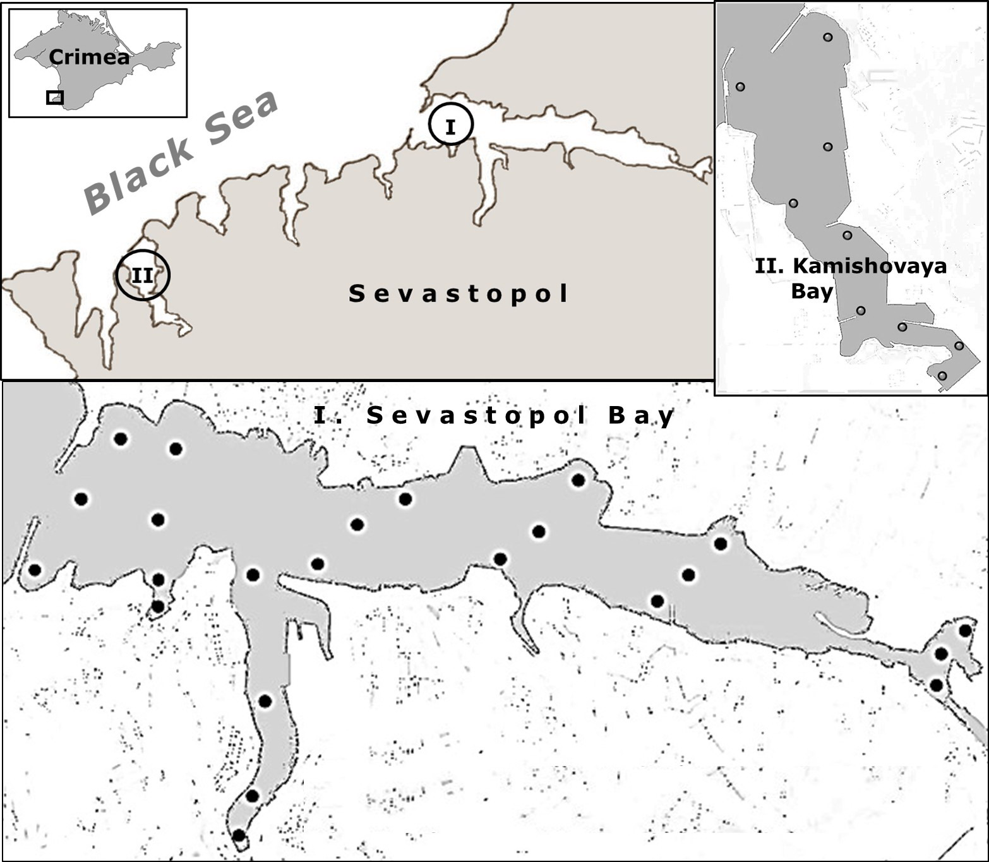
Fig. 1. Map-scheme the Sevastopol coastal area, showing the bays for sampling sediment and macrofauna (2000, 2009).

Kamishovaya bay in comparison with Sevastopol Bay (Fig. 1, II) has a narrow functional development as one of the largest Fishery Port in Crimea. Port development and maintenance, fish-canning and shipbuilding factories and many others ventures that are relevant to the region's economic development are located along the coasts and define the main impact factors on the marine environment in this area.

III. Materials and methods
The methodologies for different elements of present review have largely been set out elsewhere [2, 3]. Briefly:
- Sediments were sampled by a modified Petersen dredge having the catchment area 0.025 m² from the upper 0 – 5 layer of the sediment and passed through a 2-mm mesh to remove shells and large stones before analysis. Chloroform bitumoids were determined by gravimetric method after extraction with chloroform, and hydrocarbons were extracted by using CCl₄ and determined by means of an infrared spectrophotometer Furie 1201;
- Macrofauna was likewise sampled by 0.038 m² grab (three replicates per station) and identified after sieving through a 1-mm mesh sieve. The retained material was preserved for analysis in 95% ethanol until it could be sorted, identified in terms of species level, and finally counted in the laboratory.
- The M-AMBI index [6] was used for evaluation environmental status of investigated areas.
IV. Results and discussion
Bottom sediments: physical-chemical indices and pollution factor
Table 1 sets out the main physical-chemical characteristics of bottom sediments in each studied area. Majority the sediments were presented by aleuro-pelitic silts (from gray to black silts) characterized by high sorptive capacity. Mixed deposits (the sands with mollusk shells, light silts etc.) were observed only on separate stations. Sharp smell of the hydrogen sulfide and mazut was characteristic almost for all sediments of Sevastopol Bay and the samples of the top of Kamishovaya bay. As a general trend of sedimentary changes for both investigated areas it should be noted expansion of the areas with silt sediments by 2009 and also redistribution the sediment types, namely: a shift from a dominance the dark-grey and grey silts in 2000 to the black silts in 2009. Natural humidity on all sampling locations varied with characteristic trend of decrease the values from black to grey silts and to “others”.

Table 1. Physical-chemical indices of bottom sediments
Type sediment | Year of sampling
Type sediment | 2000 |  | 2009 | 2000 |  |  | 2009 | 2000 |  | 2009
Type sediment | Eh range, mV |  |  | pH range |  |  |  | Humidity, %
Sevastopol bay
Silts (84.2÷92.5%)*  Others** (15.5÷7.0) | +21…-189  +251…-114 |  | -55…-247  -20… -29 | 7.0…8.0  7.9…8.2 |  |  | 7.1…7.8  7.5…7.7 | 42.0…78.5  26.5…72.7 |  | 35.8…69.2  18.0…33.5
Kamishovaya bay
Silts (55.5÷66.6)  Others (44.4÷33.3) | -39…-159  +6…+101 | -14…-59  +36…+276 |  |  | 7.3…7.8  7.7 | 7.6…7.9  8.0…8.0 |  |  | 39.8…58.3  25.0…33.5 |  | 28.2…52.0  28.2…32.9
Note: * % from total number stations; ** the sands, mollusk shells or mixed substratum

The Eh and pH have varied within the boundaries of each bay but the pH ranges have been similar for both areas that testifies about relatively stable fluctuations of acid-base balance in bottom surface as a whole (from near neutral up to weakly alkaline conditions) (Fig. 2). Dominance of the sediments with negative Eh characterized the greatest area of bottom surface of Sevastopol Bay in 2000; the oxidative conditions (or close to those) were registered only on separate sites close to the Bay entrance but in 2009, the sediments with such conditions have not been detected any more (Fig. 2, A). Gradient of Eh in Kamishovaya bay (2000, 2009) was characterized by expressed transition from reductive to oxidative conditions in direction from the top to the seaward sites and some improvement of a situation was showed, first of all, in narrowing a range of negative values in 2009 (Fig. 2, B).
Evaluation an overall environmental status of bottom surface with use the calculated index rH₂ (rH₂ = Eh/30 + 2pH) has shown the variations from 8.5 to 24.5 in 2000 and from 6.7 to 26.0 in 2009 for both studied areas. According to relevant classifications [4, 5], the ranges 11–16 or 0 < rH₂ > 12–13 testify about dominance the sediments with reductive or anaerobic conditions, 12–13 < rH₂ > 18–20 – microaerobic and rH₂ > 19–20 – with aerobic correspondingly. Taking into account the registered prevalence of silt sediments with negative Eh (Fig. 2), it could be concluded that greater area of a bottom surface of investigated regions in 2009 have characterized by unfavorable conditions, that in turn determines an activity of biogeochemical processes on accumulation/transformation of received pollutants (Table 2).

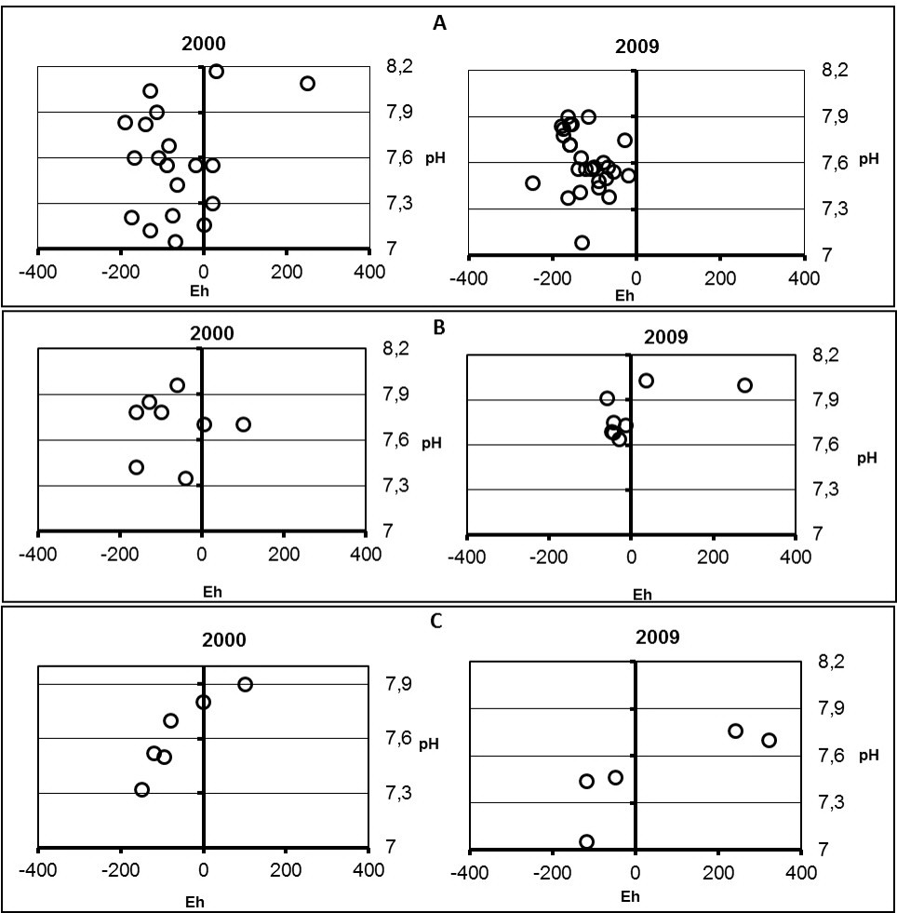
Eh (mV)
Eh (mV)
Eh (mV)
Eh (mV)
Fig. 2. Eh – pH diagrams (A. Sevastopol Bay; B. Kamishovaya bay).

Table 2 shows that the ranges of oil hydrocarbons (OH) and chloroform bitumoids (ChlB) in bottom sediments are changed depend on the sediment type but in general have been more high in Sevastopol Bay. Extremely high concentrations of the OH and ChlB, registered in the silt sediments with stable negative redox potential, were characteristic for sediments of both bays.

Table 2. The ranges of oil hydrocarbons and chloroform bitumoids in bottom sediments (mg/100 g dry sediment)
Type of sediment | Oil hydrocarbons |  | Chloroform bitumoids
Type of sediment | 2000 | 2009 | 2000 | 2009
Type of sediment | max…min | max…min | max…min | max…min
Sevastopol Bay
Silts  Others | 1708.8 … 34.0  710.4 … 1.0 | 1369.5 ... 19.0  189.3 … 24.3 | 3560.0 … 240.0  80.0 … 50.0 |  | 2520.0 … 270.0  510.0 … 110.0
Kamishovaya bay
Silts  Others | 88.0 … 7.0  52.0 … 7.0 | 158.8 … 39.7  7.1 … 1.9 | 780.0 … 110.0  240.0 … 50.0 |  | 455.0 … 145.0  38.0 … 12.0

Pollution gradients in sediments of Sevastopol Bay in 2000 and 2009 are similar and coincide with relevant trends for oxidative-reductive potential. It is evident, that a central part of the Bay together with adjoining areas (several small bays in frames of total aquatoria) remains a zone of maximal anthropogenic load during decade (Fig. 3, A, B). In spite of a decline of total anthropogenic load to the Bay by 2009, the oil hydrocarbons and chloroform bitumoids have already been registered on sampling locations close to the open sea (an entrance to the Bay).
Two areas that have been already outlined by spatial gradient of Eh (Fig. 2, B), characterize the spatial distribution of the pollution in sediments of Kamishovaya bay, namely: from the top to the centre and then in direction to the bay mouth (Fig. 3, C, D). Average levels of
the pollution in 2000 and 2009 were practically similar but the absolute concentrations of oil hydrocarbons in sediments of apical part have increased in 1.4 time but declined in 1.2 time on the sites close to outer part of the bay. In terms of the bitumoids, a corresponding pressure for the most sampling sites by 2009 has declined (Fig. 3, D).
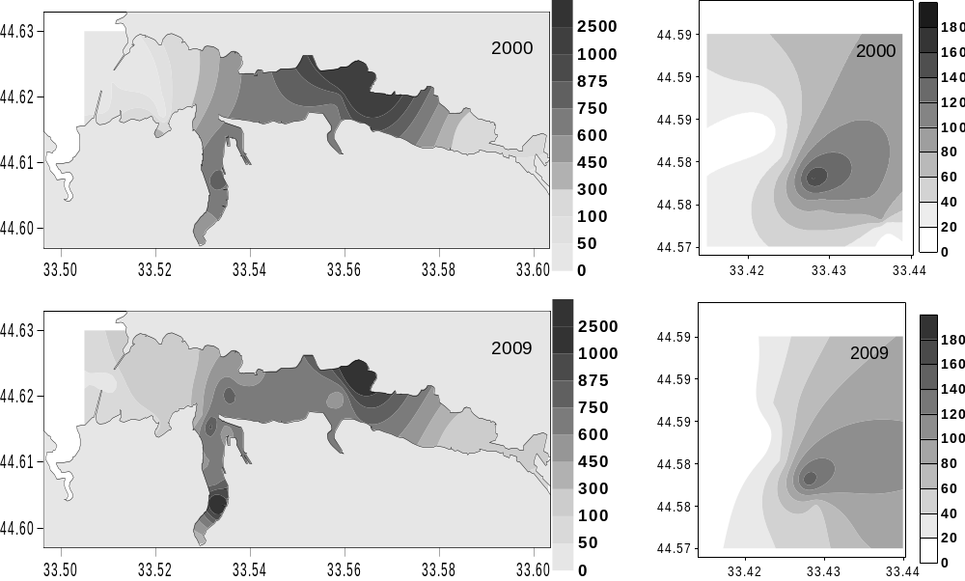
Fig. 3. Pollution factors in the Sevastopol (A, B) and Kamishovaya (C, D) bays.
C.
А.
B.
D.

ii. Macrozoobenthos
Registered decline of overall pollution pressure to investigated areas over time was accompanied by the changes in macrobenthic communities but with expressed differences for each bay. Surveys of the Sevastopol Bay have shown a decrease of total number of macrozoobenthos species up to 52 species in 2009 vs 68 in 2000, redistribution of species occurrence (Table5) and overall decrease of all quantitative indices by 2009 (Fig. 4).
Main contributions to a total biomass of macrozoobenthos in 2000 were made by the mollusks: in most degree the bivalves and in less – the gastropods. Mytilus galloprovincialis, Mytilaster lineatus with maximal values dominated in the centre and mouth of the Bay. Nassarius reticulatus, Abra segmentum and Cerastoderma glaucum with enough high biomass were marked practically everywhere, and a share the polychaetes and crustaceans in total biomass was not very large but their contribution to a total abundance was significantly higher. General trend of benthic abundance in 2000 was characterize by a growth of corresponding indices from the top to the Bay mouth and also by the variety of assemblages responsible for this growth, namely: C. glaucum – N. reticulatus – A. segmentum dominanted in the top, N. reticulatus – C. glaucum – in the central part and at the Bay mouth. The mollusks Loripes lucinalis, Spisula subtruncata, Chamelea gallina, characteristic for slightly polluted areas, were registered at the Bay mouth with enough high values of biomass. Trophic structure the macrozoobenthos of this period, in view of a wide spread of Cerastoderma and mussels on the most sampling area, was characterized by the dominance of sestonophagues.

Table 5. Occurrence (%) of the main macrozoobenthos species in Sevastopol Bay
Species | Year |  | Species | Year
Species | 2000 | 2009 | Species | 2000 | 2009
Capitella capitata | 81 | 31.6 | Melinna palmata | 31 | -
Iphinoe elisae | 81 | 26.3 | Rissoa parva | 31 | 16
Cerastoderma glaucum | 75 | 42.1 | Diogenes pugilator | 25 | 21
Nassarius reticulatus | 69 | 26.3 | Mytilus galloprovincialis | 25 | 11
Abra segmentum | 69 | 57.9 | Gammaridae | 50 | -
Heteromastus filiformis | 63 | 73.7 | Oligochaeta | - | 36.8
Bittium reticulatum | 56 | 36.8 | Abra nitida | 19 | 36.8
Hydrobia acuta | 56 | 78.9 | Tellina fabula | - | 36.8
Balanus improvisus | 50 | 36.8 | Polydora ciliata | 19 | 31.6
Nephtys hombergii | 44 | 31.6 | Spisula subtruncata | 13 | 26.3
Mytilaster lineatus | 44 | 36.8 | Neantes succinea | 19 | 26.3
Parvicardium exiguum | 38 | 21

In comparison with 2000, the biomass of macrozoobenthos in Sevastopol Bay by 2009 have dropped throughout all sampling area with the minimum of less than 1.0 g/m² in the centre and on some sites close to the Bay entrance (Fig. 4). Analogous trend was marked for abundance but with more significant decline at the mouth. At the same time, a significant increase of the abundance was observed in the top and central parts owing to gastropoda Hydrobia acuta and polychaete Heteromastus filiformis (in the centre), and also A. segmentum – but only in apical Bay part. Dramatic changes have concerned the mollusks M. galloprovincialis and M. lineatus, namely: being one of the main “investors” in total biomass and abundance (only M. lineatus) of macrozoobenthos in 2000, the first in 2009 have not been detected in any sampling location, and the biomass and abundance of M. lineatus have declined on two orders.
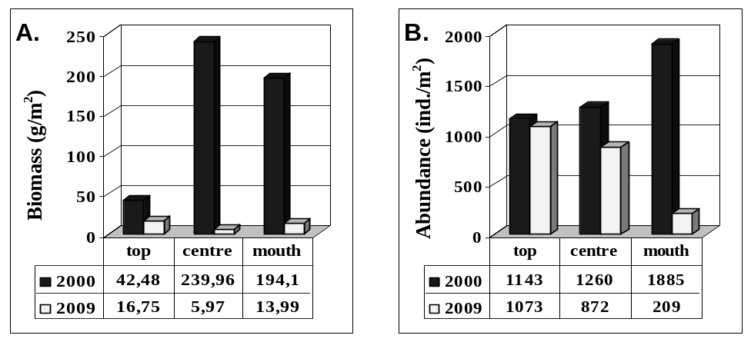
Fig. 4. Average biomass (A) and abundance (B) of macrozoobenthos in Sevastopol Bay.

The number of macrozoobenthic species in Kamishovaya bay has not undergone substantial changes during decade and has been in range 58 – 60 species. Species occurrence did not show such great fluctuations as in Sevastopol Bay with exception Modiolus adriaticus which were detected only in 2000 and Aricidea (Acmira) cerrutii, Nephtys cirrosa, Oligochaeta and Spisula subtruncata registered in 2009 (Table 6). Nevertheless, in 2009 a decline of average values of the biomass and abundance has been also registered on all sampling locations (Fig.5). If by the major contributors in total biomass of 2000 were bivalvia – M. lineatus, C. glaucum, Ch. gallina, A. segmentum and gastopoda N. reticulatus, in 2009 this assemblage was replaced by C. glaucum, Ch. gallina, Pitar rudis. A similar replacement of dominating complexes were observed for a total abundance, namely: M. lineatus, Melinna palmata, Bittium reticulatum, Balanus improvisus, Abra segmentum, Rissoa parva responsible for maximal contributions in 2000 and Heteromastus filiformis, Bittium reticulatum, Cerastoderma glaucum, Parvicardium exiguum, Pitar rudis in 2009 but with a much lower quantitative indices.

Table 6. Occurrence (%) of the main species of macrozoobenthos in Kamishovaya bay
Species | Year |  | Species | Year
Species | 2000 | 2009 | Species | 2000 | 2009
Abra segmentum | 100.0 | 22.2 | Nephtys hombergii | 33.3 | 33.3
Melinna palmata | 88.9 | 11.1 | Iphinoe elisae | 33.3 | 33.3
Cerastoderma glaucum | 77.8 | 66.7 | Chamelea gallina | 33.3 | 66.7
Bittium reticulatum | 77.8 | 66.7 | Heteromastus filiformis | 22.2 | 88.9
Mytilaster lineatus | 77.8 | 33.3 | Parvicardium exiguum | 22.2 | 88.9
Modiolus adriaticus | 66.7 | - | Ampelisca diadema | 11.1 | 33.3
Balanus improvisus | 66.7 | 22.2 | Diogenes pugilator | 11.1 | 66.7
Harmothoe reticulata | 55.6 | 22.2 | Abra nitida | 11.1 | 33.3
Tricolia pullus | 55.6 | 11.1 | Gouldia minima | 11.1 | 44.4
Dexamine spinosa | 55.6 | - | Lucinella divaricata | 11.1 | 44.
Capitella capitata | 44.4 | 11.1 | Pitar rudis | 11.1 | 55.6
Prionospio cirrifera | 44.4 | 11.1 | Aricidea cerrutii | - | 44.4
Protodorvillea kefersteini | 44,4 | 22,2 | Nephtys cirrosa | - | 33.3
Nassarius reticulatus | 44.4 | 11.1 | Oligochaeta | - | 55.6
Rissoa parva | 44.4 | 22.2 | Spisula subtruncata | - | 66.7

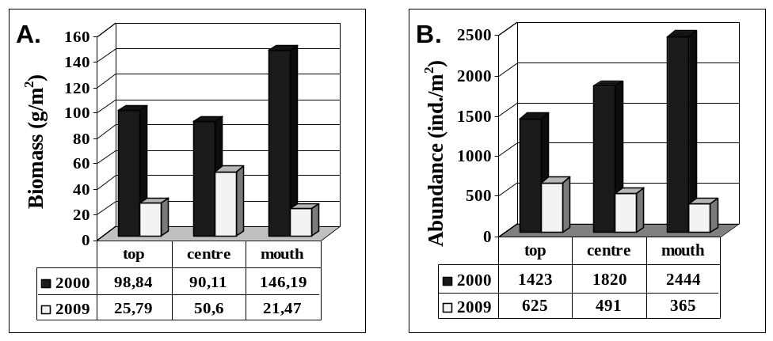
Fig. 5. Changes of average biomass (A) and abundance (B) of macrozoobenthos in Kamishovaya bay.
Comparison of species diversity (on the Shannon index) showed the variations both between the studied areas and between different sites of the same bay (Table 7). Throughout the period, relevant indices were lower in Sevastopol Bay and the increase of species diversity in terms of biomass in central part by 2009 can be noted as the only positive temporal trend for this aquatoria. More expressed the changes in species diversity in Kamishovaya bay were observed between the different areas: a growth of relevant indices at the bay top with simultaneous decline of diversity values in the centre and at the mouth by 2009.

Table 7. Species diversity (on the Shannon index) in terms of biomass and abundance
Average  for: | Sevastopol Bay |  |  |  | Kamishovaya bay
Average  for: | Biomass |  | Abundance |  | Biomass |  | Abundance
Average  for: | 2000 | 2009 | 2000 | 2009 | 2000 | 2009 | 2000 | 2009
Total | 1.53 | 1.40 | 2.55 | 1.99 | 2.07 | 2.03 | 3.02 | 3.33
Top | 1.66 | 1.48 | 2.48 | 1.75 | 1.60 | 2.06 | 2.39 | 2.91
Centre | 0.70 | 1.61 | 2.19 | 1.73 | 2.12 | 1.85 | 2.97 | 3.44
Mouth | 1.76 | 1.16 | 2.78 | 2.42 | 2.48 | 2.17 | 3.70 | 3.65

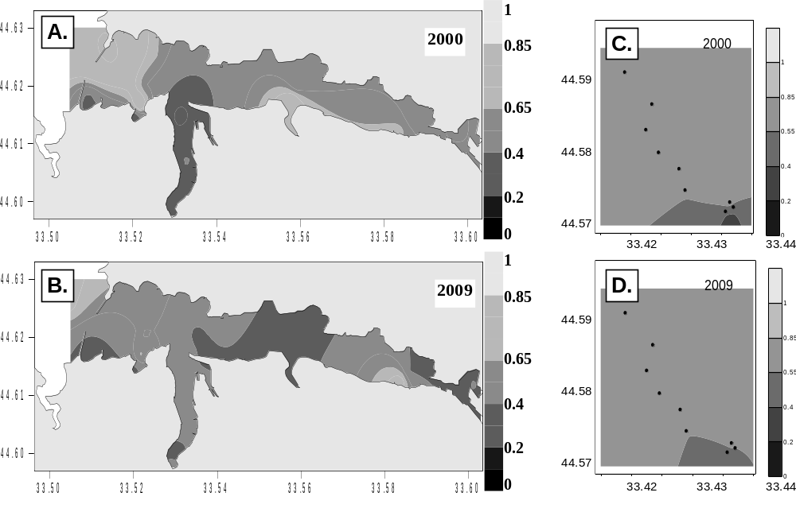
Evaluation of bottom macrofauna status through index M-AMBI [6] have shown a considerable deterioration of environmental status over time in Sevastopol Bay (Fig. 6, A). Relevant indexes for the Sevastopol Bay in 2009 have testified about the general and essential deterioration of environment, namely: the number of sites with “the good ecological status” has decreased up to 7 % against 26 % in 2000, and the area with “poor” environmental conditions has expanded up to 33 % against 20 % accordingly (Fig. 6, A).

Fig.6. Environmental status of investigated areas according to M-AMBI index (A. Sevastopol Bay; B. Kamishovaya bay)

M-AMBI indices in Kamishovaya bay did not significantly changed over time: the sampling locations in the top of area corresponded to a “moderate status”, and a “good” environmental conditions were registered in the rest of the bottom area during the surveys and of 2000 and 2009 (Fig. 6, B).

III. Conclusions
Numerous bays of Sevastopol coastal area exhibit different and peculiar characteristics depending on their natural and functional (with view of economic use) features. Stationary and constantly operating sources of the pollution shape the zones of high anthropogenic pressure in frames of each area, and temporal (long-term) stability of such "hot points" is reflected on physical-chemical properties of bottom sediments and often maintained by specific hydrodynamic regime. Mutually dependent and/or correlating environmental variables in aggregate define conditions of life for inhabiting biota and spatial trends in all macrobenthic community measures (the number of species, occurrence, biomass, abundance, H’, M-AMBI) cited in present review, have confirmed this regularity.
In case of the Sevastopol Bay, the significant role of terrigenous component due to inflowing of the Chernaya river and from the adjoining catchment area to overall sedimentation, special hydrodynamic regime with the presence of dynamic anticyclonic formation in the Bay centre have effect on the dynamics and distribution of facies of the bottom sediments and on accumulation/transfer of substances composing the sediments. Together with objective irregularity in distribution of numerous sources of the pollution both from the land based and marine activities, all these factors determine not only the special zones of high ecological pressure but maintain a chronic levels of pollution including by oil hydrocarbons of overall Bay during decades. So, a decrease in general level of anthropogenic load does not lead to mandatory or appreciable improvement of the basic characteristics of bottom macrofauna, since already accumulated volumes the pollutants require a prolonged period of transformation/utilization.
As opposed to Sevastopol Bay, an aquatoria of Kamishovaya bay has a narrow-target development based on exceptionally the port's goods and services that according to present legislation should provide special measures to reconcile the port functioning and marine environment protection, as for example, the regular bottom-cleaning or bottom-dredging works. According to the results presented in present review, total environmental status the bottom sediments of Kamishovaya bay has ranged from "moderate" to "good" indicating that an observance the nature - conservative requirements is capable to support sustainable conditions of marine environment during decade.

IV. References
[1] O. Mironov, S. Alyomov, T. Osadchaya, “Long term monitoring of benthic communities in Sevastopol Bay (Black Sea)”, A Gateway to Sustainable Development. Proc. 30-th Int. Conf. "Pacem in Maribus: A Year after Johannesburg. Ocean Governance and Sustainable Development: Ocean and Coast – a Glimpse into the Future, Kiev, October 2003, pp. 141-146.
[2] O. Mironov, L. Kiryukhina, S. Alyomov et al., “Sanitary-biological aspects of the Sevastopol bays ecology in XX century”, ECOSI-Hydrophysics Publ., Sevastopol, 2003, 185 p. (in Russian).
[3] T. Osadchaya, E. Ovsyaniy, R. Kemp et all., “Organic carbon and oil hydrocarbons in Sevastopol Bay (Black Sea)”, Marine Ecological Journal, Sevastopol, vol. II, N2, 2003, pp. 32-37. (In English).
[4] L. Kiryukhina, O. Mironov, “Chemical and bacterial characteristics of marine bottom sediments in Sevastopol Bays in 2003”, Ekologiya morya, Sevastopol, Iss.66, 2004, pp. 53-58. (in Russian).
[5] A. Polteva, E. Latkovskaya, A. Leonov, “Assessment of the background ecological state of water in the Chayvo Bay, northeastern Sakhalin”, Water Resources, Moscow, vol. 36, N1, 2009, pp. 86-98. (in Russian).
[6] A. Borja, A. Josefson B., A. Miles et al., “An approach to the intercalibration of benthic ecological status assessment in the North Atlantic ecoregion, according to the European Water Framework Directive”, Marine Pollution Bulletin, 55, 2007, pp. 42-52.

